**To install git client:**

apt-get install software-properties-common

add-apt-repository ppa:git-core/ppa -y

apt-get update

apt-get install git -y

git --version

Configure local, global and system setting for git

Local settings

git status

git config --list

git config --local user.name kanna

git config --local user.email kanna@gmail.com

git config --list

git config --list --show-origin

git config –list

git config --local core.editor vim

git config --local –edit or change the file directly using any editor

Global settings

echo $HOME

git config --global user.name kanna-global

git config --global user.email kanna-global@gmail.com

git config –list

git config --global core.editor vim

git config --global –edit or change the file directly using any editor

System settings

cat .gitconfig

git config --system user.name kanna-sys

git config --system user.email kanna-sys@gmail.com

git config --list

git config --list --show-origin

git config --system core.editor vim

git config --system –edit or change the file directly using any editor

root@ip-172-31-21-150:~/proj-1# git init

hint: Using 'master' as the name for the initial branch. This default branch name

hint: is subject to change. To configure the initial branch name to use in all

hint: of your new repositories, which will suppress this warning, call:

hint:

hint: git config --global init.defaultBranch <name>

hint:

hint: Names commonly chosen instead of 'master' are 'main', 'trunk' and

hint: 'development'. The just-created branch can be renamed via this command:

hint:

hint: git branch -m <name>

Initialized empty Git repository in /root/proj-1/.git/

root@ip-172-31-21-150:~/proj-1# git config --local user.name kanna-local

root@ip-172-31-21-150:~/proj-1# git config --local user.email kanna-local@gmail.com

root@ip-172-31-21-150:~/proj-1# git config --list

user.name=kanna-global

user.email=kanna-global@gmail.com

core.editor=vim

core.repositoryformatversion=0

core.filemode=true

core.bare=false

core.logallrefupdates=true

user.name=kanna-local

root@ip-172-31-21-150:~/proj-1# git config --local core.editor vim

root@ip-172-31-21-150:~/proj-1# git config --local --edit

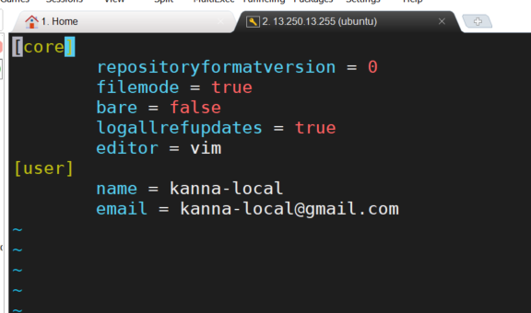

root@ip-172-31-21-150:~# git config --global --edit

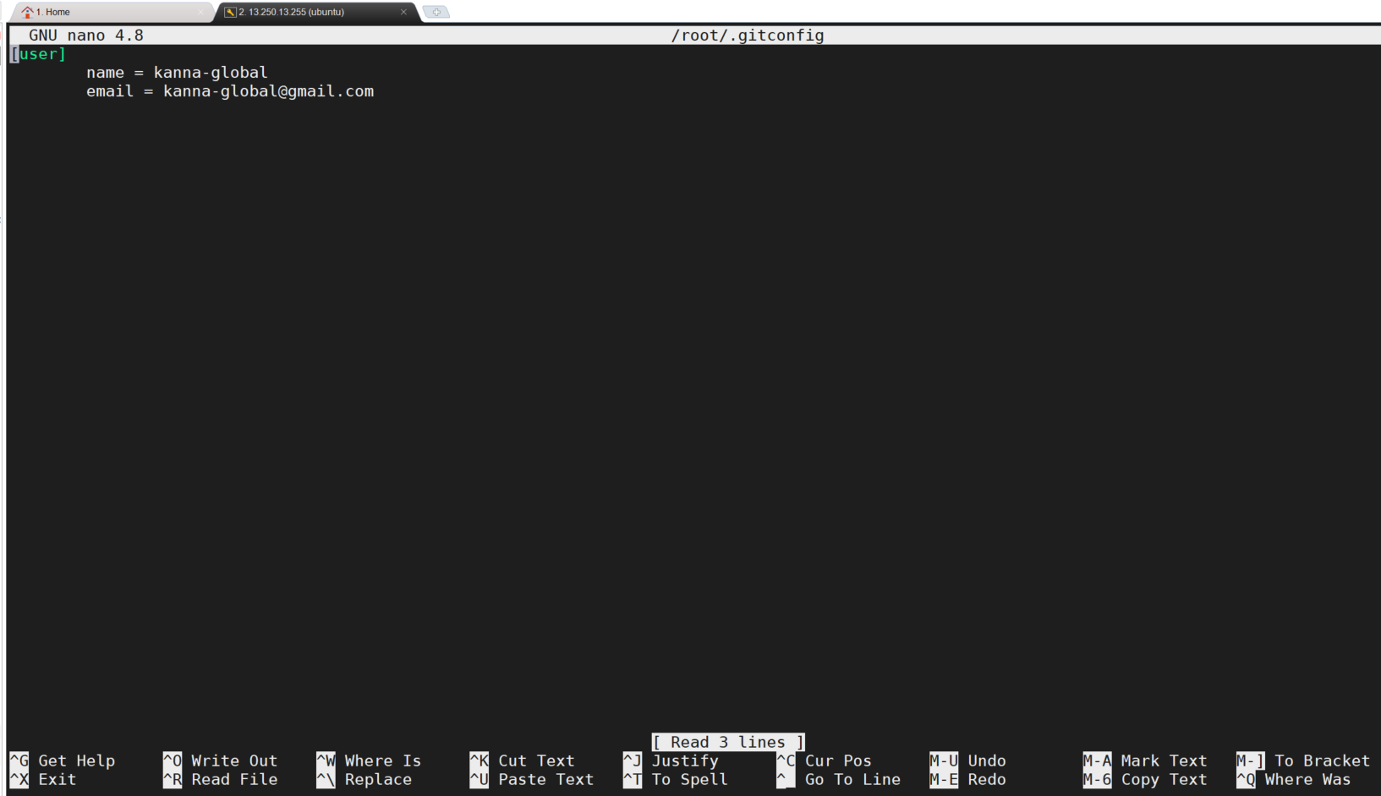

root@ip-172-31-21-150:~/proj-1# touch one.java two.java

root@ip-172-31-21-150:~/proj-1# git status

On branch master

No commits yet

Untracked files:

(use "git add <file>..." to include in what will be committed)

one.java

two.java

nothing added to commit but untracked files present (use "git add" to track)

root@ip-172-31-21-150:~/proj-1# git add one.java

root@ip-172-31-21-150:~/proj-1# git status

On branch master

No commits yet

Changes to be committed:

(use "git rm --cached <file>..." to unstage)

new file: one.java

Untracked files:

(use "git add <file>..." to include in what will be committed)

two.java

root@ip-172-31-21-150:~/proj-1# touch 3.java 4.java 5.xml

root@ip-172-31-21-150:~/proj-1# git status

On branch master

No commits yet

Changes to be committed:

(use "git rm --cached <file>..." to unstage)

new file: one.java

Untracked files:

(use "git add <file>..." to include in what will be committed)

3.java

4.java

5.xml

two.java

root@ip-172-31-21-150:~/proj-1# git add .

root@ip-172-31-21-150:~/proj-1# git status

On branch master

No commits yet

Changes to be committed:

(use "git rm --cached <file>..." to unstage)

new file: 3.java

new file: 4.java

new file: 5.xml

new file: one.java

new file: two.java

**To store in git local repo: (git records the changes when the files are in local repo)**

root@ip-172-31-21-150:~/proj-1# git commit -m "all files - first commit"

[master (root-commit) 8ca956a] all files - first commit

5 files changed, 0 insertions(+), 0 deletions(-)

create mode 100644 3.java

create mode 100644 4.java

create mode 100644 5.xml

create mode 100644 one.java

create mode 100644 two.java

root@ip-172-31-21-150:~/proj-1# git status

On branch master

nothing to commit, working tree clean

root@ip-172-31-21-150:~/proj-1# git log

commit 8ca956a45b410c1d39b92cb848cbb8d20ceff881 (HEAD -> master)

Author: kanna-local <kanna-local@gmail.com>

Date: Sat Apr 16 01:15:04 2022 +0000

all files - first commit

root@ip-172-31-21-150:~/proj-1# git status

On branch master

nothing to commit, working tree clean

root@ip-172-31-21-150:~/proj-1# ls

3.java 4.java 5.xml one.java two.java

root@ip-172-31-21-150:~/proj-1# touch hello.java

root@ip-172-31-21-150:~/proj-1# ls -l

total 0

-rw-r--r-- 1 root root 0 Apr 16 01:12 3.java

-rw-r--r-- 1 root root 0 Apr 16 01:12 4.java

-rw-r--r-- 1 root root 0 Apr 16 01:12 5.xml

-rw-r--r-- 1 root root 0 Apr 16 01:21 hello.java

-rw-r--r-- 1 root root 0 Apr 16 01:09 one.java

-rw-r--r-- 1 root root 0 Apr 16 01:09 two.java

root@ip-172-31-21-150:~/proj-1# echo "Hi I am modifiying it" >> one.java

root@ip-172-31-21-150:~/proj-1# git status

On branch master

Changes not staged for commit:

(use "git add <file>..." to update what will be committed)

(use "git restore <file>..." to discard changes in working directory)

modified: one.java

Untracked files:

(use "git add <file>..." to include in what will be committed)

hello.java

no changes added to commit (use "git add" and/or "git commit -a")

root@ip-172-31-21-150:~/proj-1#

root@ip-172-31-21-150:~/proj-1# git add .

root@ip-172-31-21-150:~/proj-1# git status

On branch master

Changes to be committed:

(use "git restore --staged <file>..." to unstage)

new file: hello.java

modified: one.java

root@ip-172-31-21-150:~/proj-1# git commit -m "mod one.java and first commit to hello.java"

[master 3466d45] mod one.java and first commit to hello.java

2 files changed, 1 insertion(+)

create mode 100644 hello.java

root@ip-172-31-21-150:~/proj-1# git status

On branch master

nothing to commit, working tree clean

root@ip-172-31-21-150:~/proj-1#

changing a single file:

root@ip-172-31-21-150:~/proj-1# echo "Hi I am modifiying it" >> two.java

root@ip-172-31-21-150:~/proj-1# git status

On branch master

Changes not staged for commit:

(use "git add <file>..." to update what will be committed)

(use "git restore <file>..." to discard changes in working directory)

modified: two.java

no changes added to commit (use "git add" and/or "git commit -a")

root@ip-172-31-21-150:~/proj-1# git add two.java

root@ip-172-31-21-150:~/proj-1# git status

On branch master

Changes to be committed:

(use "git restore --staged <file>..." to unstage)

modified: two.java

root@ip-172-31-21-150:~/proj-1# git commit -m "modified two.java"

[master 757171d] modified two.java

1 file changed, 1 insertion(+)

root@ip-172-31-21-150:~/proj-1# git status

On branch master

nothing to commit, working tree clean

root@ip-172-31-21-150:~/proj-1# git log

commit 757171dba93599a5ccba23e1c6aede5dbbb0bfd0 (HEAD -> master)

Author: kanna-local <kanna-local@gmail.com>

Date: Sat Apr 16 01:26:42 2022 +0000

modified two.java

commit 3466d4588d708a98eebf2be219fa980576fcf4cc

Author: kanna-local <kanna-local@gmail.com>

Date: Sat Apr 16 01:24:00 2022 +0000

mod one.java and first commit to hello.java

commit 8ca956a45b410c1d39b92cb848cbb8d20ceff881

Author: kanna-local <kanna-local@gmail.com>

Date: Sat Apr 16 01:15:04 2022 +0000

all files - first commit

root@ip-172-31-21-150:~/proj-1#

|  |  |
| --- | --- |
|  |  |

HEAD always points to latest commit

|  |
| --- |
| root@ip-172-31-21-150:~/proj-1# git log  commit cbfebb5961fc7e2285eb3e0538c985d211f5ba7d (HEAD -> master)  Author: kanna-local <kanna-local@gmail.com>  Date: Sat Apr 16 01:59:02 2022 +0000  6.xml first commit  commit 757171dba93599a5ccba23e1c6aede5dbbb0bfd0  Author: kanna-local <kanna-local@gmail.com>  Date: Sat Apr 16 01:26:42 2022 +0000  modified two.java  commit 3466d4588d708a98eebf2be219fa980576fcf4cc  Author: kanna-local <kanna-local@gmail.com>  Date: Sat Apr 16 01:24:00 2022 +0000  mod one.java and first commit to hello.java  commit 8ca956a45b410c1d39b92cb848cbb8d20ceff881  Author: kanna-local <kanna-local@gmail.com>  Date: Sat Apr 16 01:15:04 2022 +0000  all files - first commit |

To avoid/exclude tracking a particular file or directory in the git repo:

Create a hidden file .gitignore

root@ip-172-31-21-150:~/proj-1# vim .gitignore

root@ip-172-31-21-150:~/proj-1# cat .gitignore

kanna.info

*.class

*.log

logs/

root@ip-172-31-21-150:~/proj-1# touch kanna.info test.info

root@ip-172-31-21-150:~/proj-1# git status

On branch master

Untracked files:

(use "git add <file>..." to include in what will be committed)

.gitignore

test.info

nothing added to commit but untracked files present (use "git add" to track)

**To add and commit concurrently**

* Once existing committed files can be added and committed concurrently
* For new files, it is not possible to add and commit using single command. The new file must be added first using git add and then only we can commit

|  |
| --- |
|  |